Safely delete a supervisor VM in TKGs

Under Administration:

Find vCenter Server Extensions:

Select vSphere ESXi Agent Manager:

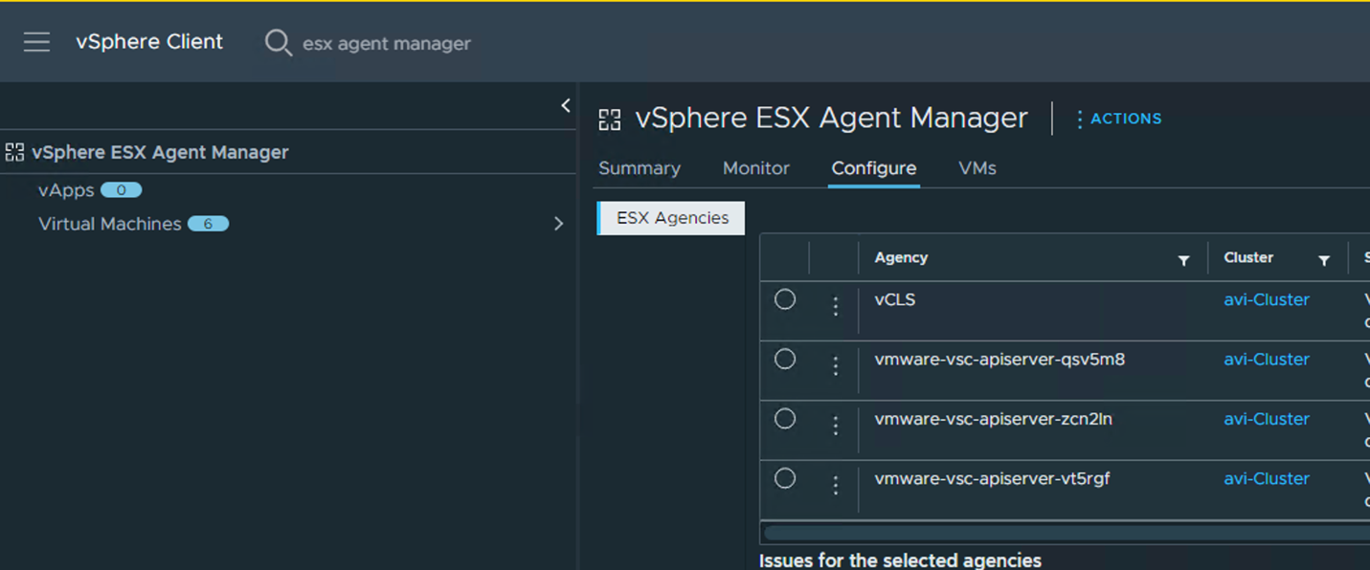

On the left one will see the supervisor VMs select the 3 little dots and select delete agency:

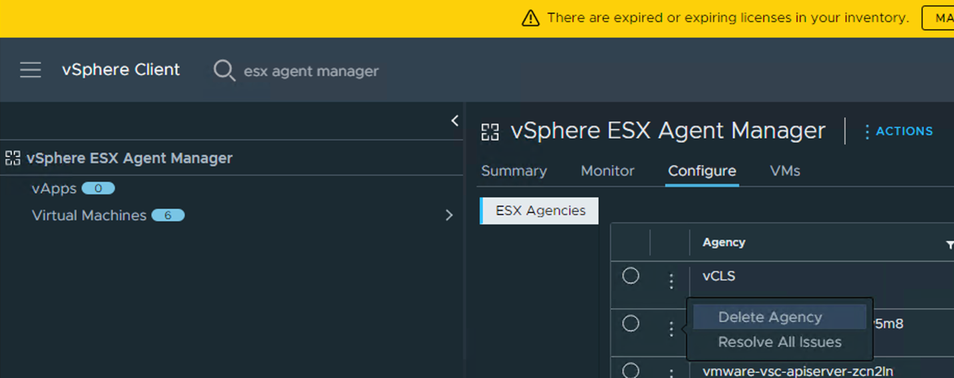

Select yes:

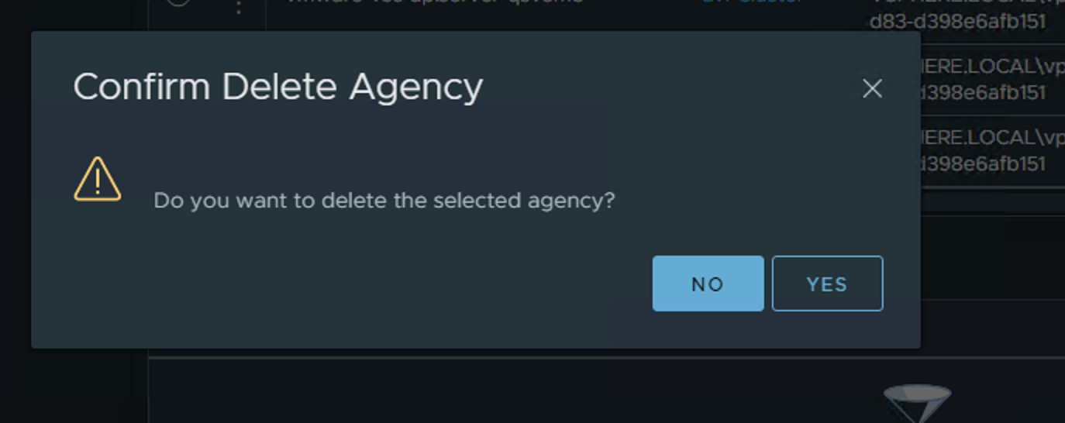

Witness one VM going down:

Result:

The name of the supervisor can be found in the notes section for the supervisor VM:

